**LABSHEET 4**

IT24102981

Jayatunga.N.P

Exercise

1. A screenshot of a computer

   Description automatically generated
2. A number of black and white text

   Description automatically generated with medium confidence

Scale of the measurement. I have scaled the data , then used that to identify the scale of the relevant data in the dataframe

1. 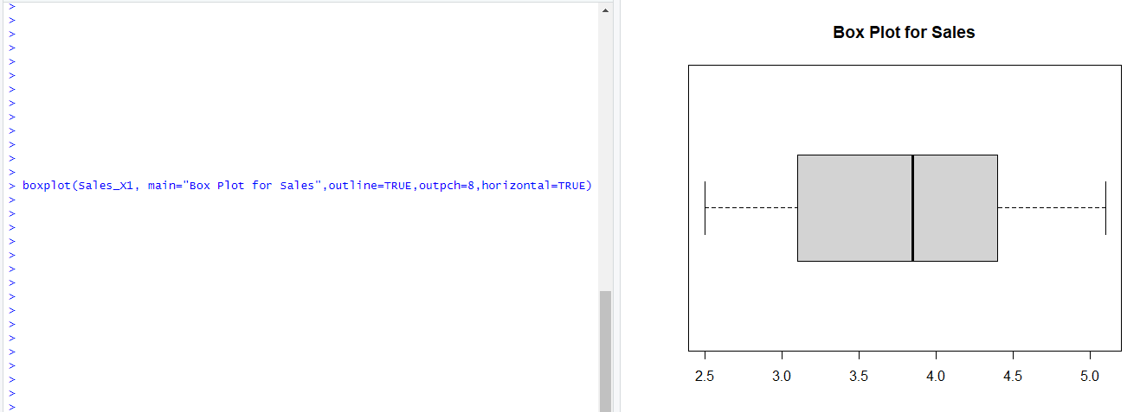

The distribution is skewed ,and it seems to be a positive skewed since the upper whisker is a bit longer and there seems to be some unusually high sales values, and since the IQR is spread out it seems to have a high variability.

1. A screenshot of a computer

   Description automatically generated

